O p e n S t u d i o s
F o r t M a s o n
She’s at it again!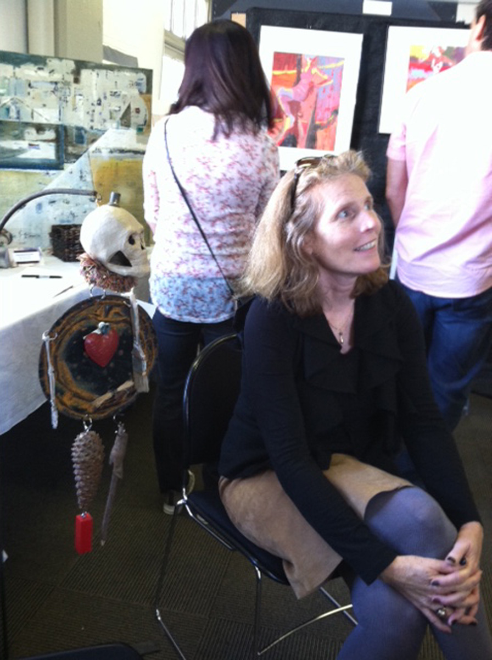 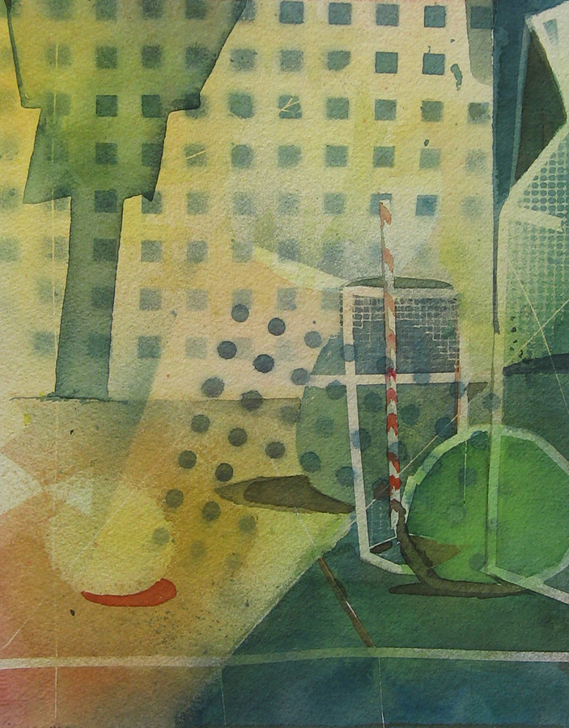

Please join us for Open studios 2014
Fort Mason: 2 Marina Blvd, San Francisco CA 94123 (415) 345-7500
Always plenty of parking and places to eat or have coffee

Sat & Sun November 8th & 9th from 11AM-6PM
Fort Mason, Building A, ground floor,
Golden Gate Room SF, CA 94123

Scholis will be featuring her latest works in Watercolor as well as hand sewn halter vests, and soft sculpture.

A truly aesthetic experience…and it’s free!

